SIMATS ENGINEERING
Department of Computer Science and Engineering
ASSESSMENT TOOL 2 – PSEUDOCODE WRITING TASK
Course Code: | CSA1220 | Course Title: | Computer Architecture
CO Assessed: | CO5 – Precision (BL4) | Assessment: | Pseudocode Writing task
Weightage: | 30% | Total Marks: | 100
CO5 Statement: | Construct I/O communication mechanisms by comparing memory-mapped and I/O-mapped techniques, interrupt handling (vectored, hardware, software), DMA controllers, and advanced bus interfaces including PCIe, USB, NVMe, and Thunderbolt.
Student Name: | P.Rishitha | Reg. No.: | 192472396
Section / Batch: | B/2024 | Date: | 26/08/26

Instructions to Students
• Identify the relevant concepts of DMA-based data transfer, vectored interrupts, I/O mapping techniques, bus arbitration, and hybrid I/O communication.
• Analyze the requirements of different I/O devices by considering CPU involvement, interrupt priority, latency, bandwidth, throughput, and transfer speed.
• Apply appropriate I/O techniques such as DMA, interrupt-driven I/O, vectored interrupts, memory-mapped I/O, I/O-mapped I/O, and bus arbitration to develop efficient solutions.
• Develop pseudocode algorithms for DMA data transfer, prioritized interrupt handling, dynamic I/O mapping selection, bus arbitration, and hybrid polling–DMA communication.
• Evaluate the proposed I/O mechanisms by interpreting CPU utilization, data transfer efficiency, interrupt response time, communication performance, resource allocation, and overall system suitability.

QUESTIONS
1. A real-time monitoring system receives data from multiple sensors with different sampling frequencies and response-time requirements. Develop a pseudocode for an interrupt scheduling mechanism that assigns suitable interrupt priorities to the sensors based on their sampling rate, urgency, and data-processing requirements. The algorithm should manage simultaneous interrupt requests and ensure that time-critical sensor data is serviced without causing excessive CPU overhead.
2. A high-speed data acquisition system must transfer continuous streams of data between an I/O device and memory while preventing data loss when the incoming data rate exceeds the processing speed of the CPU. Write a pseudocode for a double-buffered DMA mechanism that alternates between two memory buffers during data transfer. The algorithm should detect buffer completion, switch buffers, generate appropriate interrupts, and handle buffer overflow conditions.
3. A computer system contains several I/O devices with different data transfer sizes and timing requirements. Design a pseudocode for an I/O scheduling algorithm that determines the order in which pending I/O requests should be serviced. The algorithm should consider device priority, request size, waiting time, latency requirements, and available bandwidth to improve overall I/O performance while preventing starvation.
4. A high-performance embedded system uses multiple DMA-capable devices that may request memory access at the same time. Develop a pseudocode for a DMA channel arbitration mechanism that allocates memory bus access among competing DMA requests. The algorithm should consider request priority, transfer size, urgency, and fairness, while ensuring that high-priority transfers are completed within their required time constraints.
5. A real-time system must communicate simultaneously with several devices that have different communication speeds and reliability requirements. Write a pseudocode for an adaptive I/O management mechanism that monitors device performance and dynamically changes the communication method or transfer parameters when congestion, delays, or errors are detected. The algorithm should monitor transfer status, detect performance degradation, adjust resource allocation, and maintain reliable communication with minimal CPU overhead.
Code of Conduct
I P.Rishitha (192472396) (Name / Reg No) certify that this submission is my original work and that I have adhered to the guidelines specified for this assessment. I understand that any violation of academic integrity rules will result in disciplinary action.
Signature of the Student: P.Rishitha
RUBRICS FOR CALCULATION
Criteria | Weightage(%) | Level 4 – Exemplary (5 Marks) | Level 3 –  Proficient (4  Marks) | Level 2 –  Developing  (2–3 Marks) | Level 1 – Beginning (0–1 Mark)
Problem  Understanding | 20% | Identifies all inputs, outputs, constraints accurately | Minor missing  elements | Partial  understanding | Incorrect  interpretation
Algorithm  Design | 30% | Complete, correct, and logically sound solution | Minor logical  gaps | Partially correct logic | Incorrect approach
Use of Control Structures | 20% | Efficient and  appropriate use of loops, conditions, functions/modules | Minor  inefficiencies | Limited or basic usage | Incorrect or missing constructs
Pseudocode  Structure | 10% | Well-structured,  clear, consistent  format, easy to  follow | Mostly clear with minor issues | Difficult to follow in parts | Poorly structured and unclear
Completeness | 20% | Handles all cases; optimized approach | Handles most  cases; reasonable efficiency | Handles basic  cases only | Incomplete or  inefficient

Marks Evaluation:
Q.  No | Problem  Understanding  (20) |  | Algorithm  Design (30) |  | Use of  Control  Structures  (20) | Pseudocode  Structure (10) | Completeness  (20) | Total  (out of 100)
1 | / 4 |  | / 4 |  | / 4 | / 4 | / 4
2 | / 4 |  | / 4 |  | / 4 | / 4 | / 4
3 | / 4 |  | / 4 |  | / 4 | / 4 | / 4
4 | / 4 |  | / 4 |  | / 4 | / 4 | / 4
5 | / 4 |  | / 4 |  | / 4 | / 4 | / 4
 | / 20 |  | /30 |  | / 20 | / 10 | / 20 | / 100

Course Coordinator Faculty Incharge

1. Interrupt Scheduling Mechanism for Multiple Sensors

Introduction
A real-time monitoring system may receive data from multiple sensors simultaneously. These sensors can have different sampling frequencies, urgency levels, response-time requirements, and data-processing requirements. For example, a temperature sensor may send data every few seconds, whereas a fire or gas sensor may need immediate attention.
An interrupt scheduling mechanism is used to determine which sensor interrupt should be serviced first.

Interrupt Priority Assignment
The priority of each sensor can be determined using the following factors:

1. Sampling Rate
Sensors generating data more frequently may require higher priority because their data must be collected regularly.
For example:
- High sampling rate → Higher priority
- Low sampling rate → Lower priority

2. Urgency
Sensors associated with dangerous or emergency conditions should receive high priority.
Examples include:
- Fire detection sensor
- Gas leakage sensor
- Medical monitoring sensor
- Collision detection sensor

3. Response-Time Requirement
Some sensors require immediate processing within a specific time limit. These are called time-critical sensors.
For example, if a collision sensor must be processed within a few milliseconds, it should receive higher priority than a normal environmental sensor.

4. Data-Processing Requirement
Some sensor data requires complex processing, while other data can simply be stored for later processing. The scheduler should consider the processing requirement while assigning priorities.

Handling Simultaneous Interrupts
When multiple sensors generate interrupt requests at the same time, the interrupt controller compares their priority levels.
The general order can be:
Critical Priority → High Priority → Medium Priority → Low Priority
The highest-priority interrupt is serviced first.
Lower-priority interrupts remain pending until the processor becomes available.

Reducing CPU Overhead
Servicing every interrupt immediately can create excessive CPU overhead. Therefore, the system can:
- Defer non-critical interrupts.
- Group similar interrupts.
- Use interrupt coalescing.
- Process non-critical data in batches.
- Allow critical interrupts to preempt lower-priority processing.
An aging mechanism can also be used to increase the priority of interrupts that have been waiting for a long time. This prevents starvation.

Advantages
- Provides fast response to critical sensor data.
- Handles simultaneous interrupt requests.
- Prevents loss of important sensor information.
- Reduces unnecessary CPU overhead.
- Prevents starvation of low-priority sensors.
- Suitable for real-time monitoring systems.
IMPLEMENTATION :
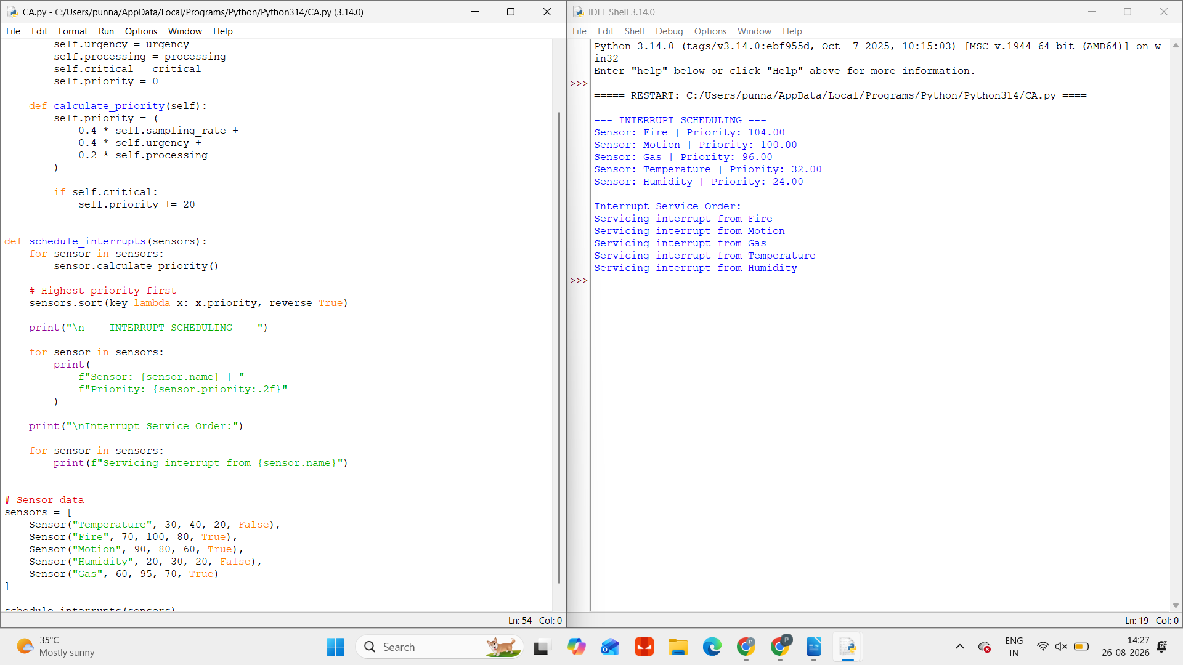

Conclusion
An interrupt scheduling mechanism ensures that sensor data is processed according to its importance and timing requirements. By considering sampling rate, urgency, response time, and processing requirements, the system can prioritize time-critical data while maintaining efficient CPU utilization.

2. Double-Buffered DMA Mechanism

Introduction
High-speed data acquisition systems continuously receive large amounts of data from I/O devices such as sensors, cameras, network devices, and storage devices.
If the incoming data rate is higher than the CPU processing speed, data may be lost. Direct Memory Access (DMA) is used to transfer data directly between an I/O device and memory without requiring continuous CPU involvement.
A double-buffered DMA mechanism uses two memory buffers to provide continuous data transfer.

Working Principle
The system contains:
- Buffer A
- Buffer B
Initially, DMA transfers incoming data into Buffer A.
While Buffer A is being filled, the other buffer remains available for processing.
When Buffer A becomes full:
- DMA detects buffer completion.
- A buffer-completion interrupt is generated.
- DMA switches to Buffer B.
- The CPU processes the data stored in Buffer A.
- DMA continues receiving new data into Buffer B.
After Buffer B is full, the process repeats by switching back to Buffer A.
Thus, one buffer is used for data acquisition, while the other is used for data processing.

Buffer Alternation
The process can be represented as:
Step 1:
Device → DMA → Buffer A
Step 2:
CPU processes Buffer A
Device → DMA → Buffer B
Step 3:
CPU processes Buffer B
Device → DMA → Buffer A
This alternating process provides continuous data transfer.

Interrupt Generation
An interrupt is generated when:
- A buffer becomes full.
- A DMA transfer is completed.
- A buffer overflow occurs.
- A transfer error occurs.
The CPU does not need to monitor every byte of incoming data. It only responds when an important event occurs, reducing CPU overhead.

Buffer Overflow
Buffer overflow occurs when both buffers are full but new data continues to arrive.
For example:
- Buffer A → Full
- Buffer B → Full
- New data → Arriving
Possible solutions include:

1. Pause the Input Device
The device is temporarily stopped until a buffer becomes available.

2. Drop Old Data
The oldest data is removed to create space for new data.

3. Drop New Data
Incoming data is discarded when no memory space is available.

4. Increase Buffer Capacity
Additional memory can be allocated if supported by the system.

Advantages
- Supports continuous high-speed data transfer.
- Reduces CPU involvement.
- Allows simultaneous data transfer and processing.
- Minimizes data loss.
- Improves system throughput.
- Suitable for real-time data acquisition.

IMPLEMENTATION :
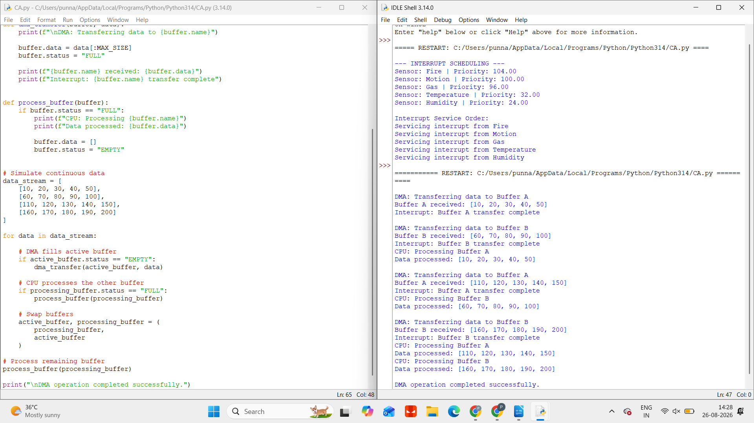

Conclusion
A double-buffered DMA mechanism improves high-speed data acquisition by alternating between two memory buffers. While one buffer receives new data, the other is processed. This ensures continuous data transfer and reduces the possibility of data loss.

3. I/O Scheduling Algorithm

Introduction
A computer system may contain several I/O devices, including:
- Keyboard
- Mouse
- Printer
- Hard disk
- SSD
- Network adapter
- Camera
- Sensors
These devices generate I/O requests with different sizes, priorities, timing requirements, and bandwidth requirements.
An I/O scheduling algorithm determines which pending request should be serviced next.

Factors Considered in I/O Scheduling

1. Device Priority
Important devices receive higher priority.
For example:
Emergency Sensor → Network Device → Storage Device → Printer
High-priority devices are serviced before less critical devices.

2. Request Size
Large I/O requests may consume more time and bandwidth.
A scheduler should balance large and small requests so that a very large request does not unnecessarily delay multiple smaller requests.

3. Waiting Time
The scheduler records how long each request has been waiting.
If a request waits for too long, its priority can gradually increase.
This process is called aging.

4. Latency Requirement
Some applications require very low response time.
Examples include:
- Video streaming
- Real-time control systems
- Online communication
- Medical monitoring
Requests with strict latency requirements receive higher priority.

5. Available Bandwidth
Before servicing an I/O request, the system checks whether sufficient bandwidth is available.
If bandwidth is limited, the scheduler may delay less important transfers.

Starvation Prevention
Starvation occurs when low-priority requests are continuously delayed because high-priority requests keep arriving.
To prevent starvation, the system uses an aging mechanism.
As the waiting time increases, the priority of the request also increases.
Eventually, the request receives service.

Benefits of Intelligent I/O Scheduling
An effective I/O scheduler:
- Reduces waiting time.
- Improves device utilization.
- Supports urgent requests.
- Prevents starvation.
- Efficiently uses available bandwidth.
- Improves overall system performance.
IMPLEMENTATION :
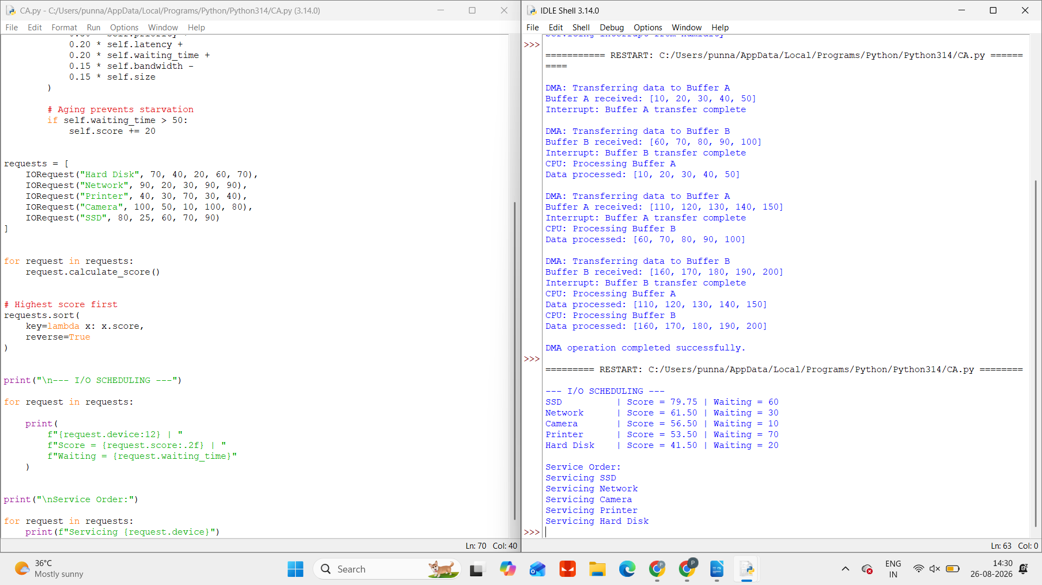

Conclusion
An I/O scheduling algorithm improves system performance by selecting requests based on priority, size, waiting time, latency requirements, and bandwidth availability. Aging ensures fairness and prevents low-priority requests from waiting indefinitely.

4. DMA Channel Arbitration Mechanism

Introduction
In a high-performance embedded system, several DMA-capable devices may request access to memory at the same time.
Examples include:
- Camera controller
- Audio device
- Network controller
- Storage controller
- Sensor interface
Since multiple devices share the memory bus, a DMA arbitration mechanism is required to decide which device receives access.

Factors Used for Arbitration

1. Request Priority
High-priority devices receive preference.
For example, a critical sensor may have higher priority than a background storage transfer.

2. Urgency
Transfers requiring immediate completion are given higher priority.
Urgency is particularly important in real-time systems.

3. Transfer Size
Large DMA transfers can occupy the memory bus for a long period.
Therefore, large transfers may be divided into smaller blocks.
This allows other devices to access the bus between transfer blocks.

4. Deadline
Some DMA transfers must be completed before a specific deadline.
Requests approaching their deadline receive increased priority.

5. Fairness
A fairness mechanism ensures that lower-priority DMA requests are not permanently blocked.
The waiting time of each request can be considered while making arbitration decisions.

DMA Arbitration Process
The general process is:
- Multiple DMA devices generate requests.
- Requests are placed in an arbitration queue.
- Priority, urgency, deadline, and waiting time are evaluated.
- The highest suitable request receives access to the memory bus.
- The transfer is performed.
- The memory bus is released.
- The next request is selected.
For large transfers, the data can be divided into smaller transfer blocks.
This prevents one device from monopolizing the memory bus.

Fairness Mechanism
A high-priority device may continuously generate requests. Without fairness, lower-priority devices may never receive memory access.
To solve this problem:
- Waiting requests receive priority increases.
- Large transfers are divided into smaller blocks.
- The memory bus is released periodically.
- Arbitration is performed again after each transfer block.

Advantages
- Supports multiple DMA devices.
- Ensures high-priority transfers meet deadlines.
- Improves memory bus utilization.
- Prevents bus monopolization.
- Provides fairness.
- Reduces waiting time.
- Suitable for embedded and real-time systems.

IMPLEMENTATION :
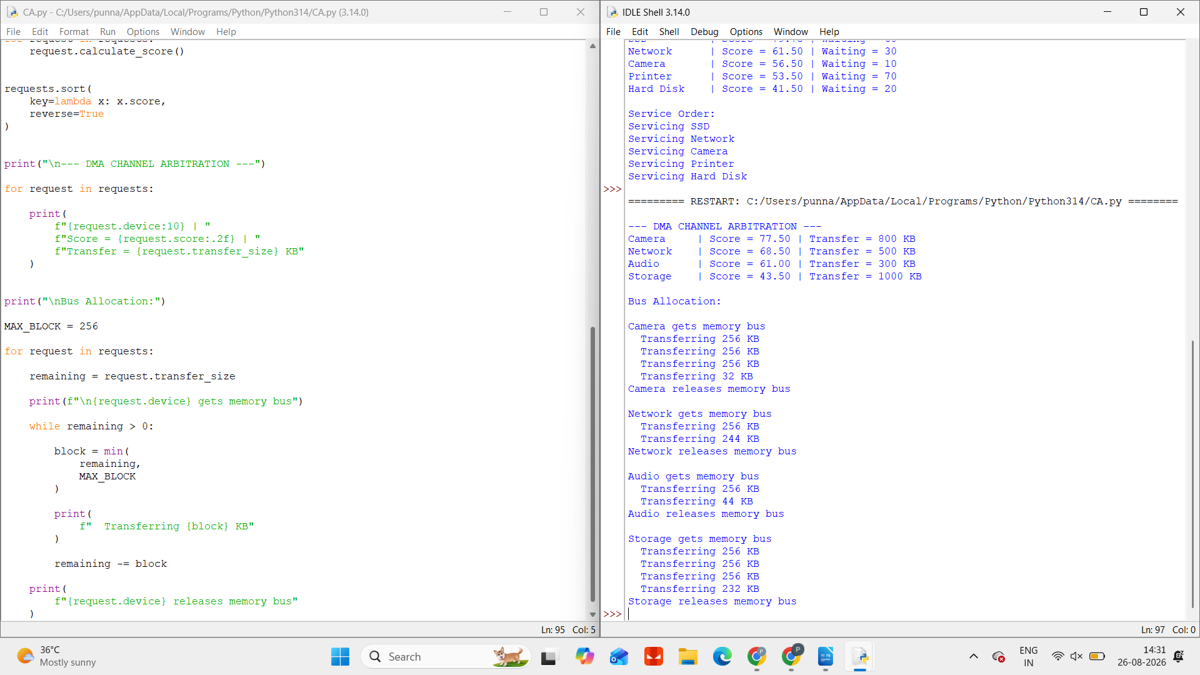

Conclusion
DMA channel arbitration manages simultaneous memory access requests from multiple devices. By considering priority, urgency, transfer size, deadlines, and fairness, the system can provide efficient and reliable DMA operation.

5. Adaptive I/O Management Mechanism

Introduction
A real-time system may communicate with multiple devices having different:
- Communication speeds
- Data transfer rates
- Reliability requirements
- Error rates
- Latency requirements
A fixed communication method may not perform efficiently under all conditions.
Therefore, an adaptive I/O management mechanism continuously monitors device performance and dynamically adjusts communication parameters when problems such as congestion, delay, or errors are detected.

Performance Monitoring
The system monitors several parameters.

1. Transfer Status
The system checks whether communication is:
- Successful
- Delayed
- Failed
- Timed out

2. Error Rate
The system records communication errors.
If the number of errors exceeds a predefined threshold, corrective action is taken.

3. Transfer Delay
The system measures the time required to complete data transfer.
If the delay becomes too high, the communication parameters can be adjusted.

4. Queue Length
A large number of pending requests may indicate congestion.

5. Bandwidth Utilization
The system monitors how much communication bandwidth is currently available.

Handling Performance Degradation

Handling Errors
If the error rate increases, the system may:
- Enable error detection.
- Enable error correction.
- Retry the transfer.
- Reduce the transfer speed.
- Change the communication method.

Handling Congestion
If the communication queue becomes too large, the system may:
- Allocate additional bandwidth.
- Reduce transfer block size.
- Prioritize critical devices.
- Delay non-critical transfers.

Handling Excessive Delay
If transfer delay exceeds the permitted limit, the system may:
- Increase device priority.
- Optimize transfer parameters.
- Allocate additional resources.
- Select a faster communication method.

Dynamic Communication Adjustment
The adaptive system can dynamically modify:
- Transfer rate
- Buffer size
- Packet size
- Retry limit
- Error correction level
- Device priority
- Communication method
For example, if a high-speed communication mode produces many errors, the system may reduce the transfer rate to improve reliability.

Reducing CPU Overhead
The adaptive I/O system can reduce CPU usage by using:

DMA
DMA transfers data directly between devices and memory.

Interrupt Coalescing
Instead of generating an interrupt for every small event, multiple events are combined into fewer interrupts.

Adaptive Monitoring
Stable devices can be monitored less frequently, while problematic devices receive more attention.

Advantages
- Dynamically responds to changing conditions.
- Detects errors and delays.
- Handles communication congestion.
- Improves reliability.
- Reduces CPU overhead.
- Optimizes bandwidth utilization.
- Supports multiple devices with different requirements.
IMPLEMENTATION :
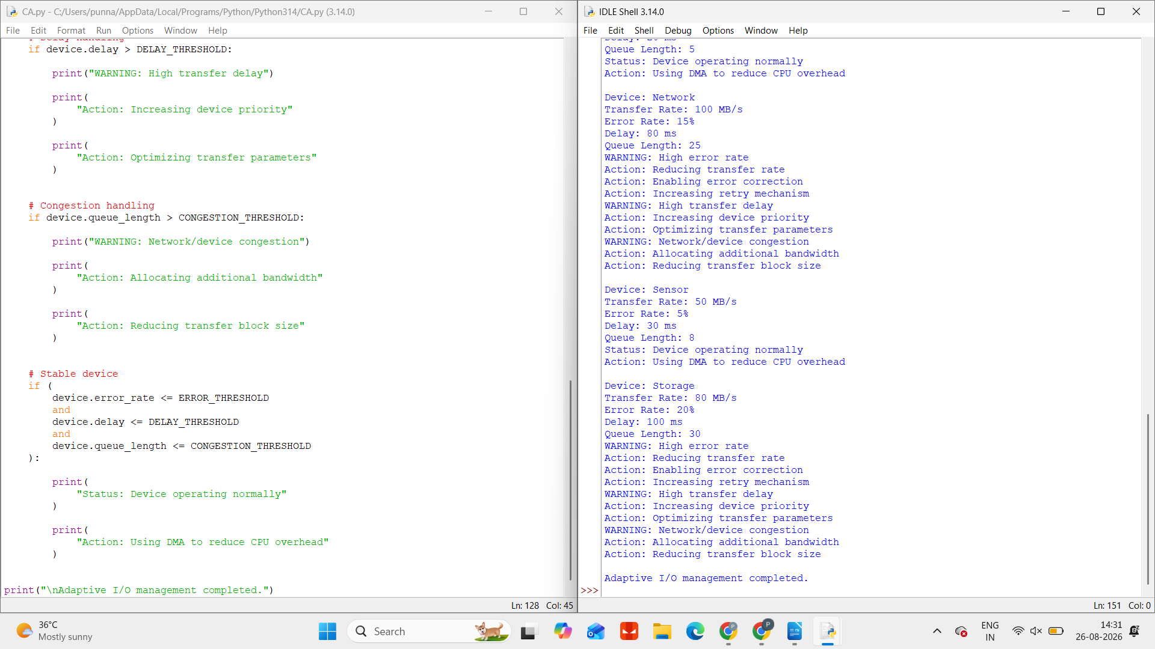

Conclusion
An adaptive I/O management mechanism continuously monitors communication performance and dynamically changes transfer parameters when degradation is detected. By adapting to congestion, delays, and errors, the system maintains reliable communication while minimizing CPU overhead and improving overall performance.

